

**Doren Aldana’s**

**Home Newsletter**

**Volume 1 Issue 1 March 2021**



These boxes throughout the document will contain TIPS to make your newsletter sell. Be sure to DELETE THESE BOXES BEFORE PRINTING AND MAILING.

These boxes throughout the document will contain TIPS to make your newsletter sell. Be sure to DELETE THESE BOXES BEFORE PRINTING AND MAILING.

Volume, Issue

December 2005

These boxes throughout the document will contain TIPS to make your newsletter sell. Be

Volume, Issue

Month, Year

***Adding Value to Your Life with News, Tips and Entertainment***

Why it's important to price your house right.



When you list your house, you want it to sell fast and at a high price. In order for that to happen, it needs to be priced right. But this is where it gets tricky. Price it too low, and it may sell quickly but you’ll leave money on the table. Price it too high, and it may take months and several price reductions to sell. The solution is to work with an experienced Realtor. Here are some of the things real estate professionals consider in setting the right price for your home:

**Ralph Smith**

**Realtor**

ABC Realty

Phone: 604-990-4303

Fax: 604-990-4305

ralph@abcrealty.com



* There isn’t one correct price for a given home: a home’s value depends on neighborhood and current market activity. This is why Realtors study recent sales of comparable properties so carefully.
* Sometimes a slightly lower price will attract extra buyers who may compete for your home and drive the price up (or eliminate the need for discounting).
* But an underpriced home can make buyers suspicious that something is wrong with the property.
* An overpriced home can sit on the market longer, which can again make buyers suspicious that something is wrong. Repeated price reductions can have the same effect.
* Research shows that the longer a house sits on the market, the lower its final selling price will be. Often, houses that start at a lower price sell more quickly and the buyer ends up making more money.
* Price categories are important. When buyers do online searches, they enter a maximum price. If you inadvertently exceed a maximum price level by even $5, a huge number of buyers who can afford your home will never see it!
* Check out websites that offer estimates of your home’s market value. This value won’t be as accurate as your Realtor’s. But buyers will be looking at these sites, so you should make sure you’re not too far off base.

If you’d like help deciding on the right price for your home, we can introduce you to one of our trusted local Realtor partners. Call us today!

**Jane Smith**

**Mortgage Advisor**

ABC Mortgage

Phone: 604-990-4303

Fax: 604-990-4305

doren@abcmortgage.com

Inside This Issue…

Why It’s Important To Price Your House Right ............................ 1

Listings of the Month .............. 2

An Easy Way To Calculate How Much House You Can Afford . 3

8 Reasons Why Oranges Are Good For You .……................ 3

Quiz of the Month ..................... 4

Home Buyer Mistakes ………… 4

Free Info Request Form ........... 5

**Listings of the Month**

**Get FREE Instant Property Info via Text Message**

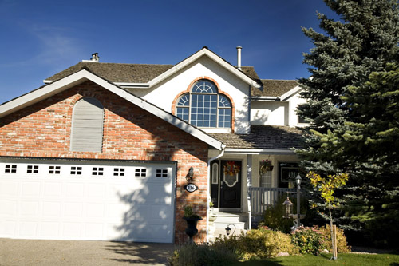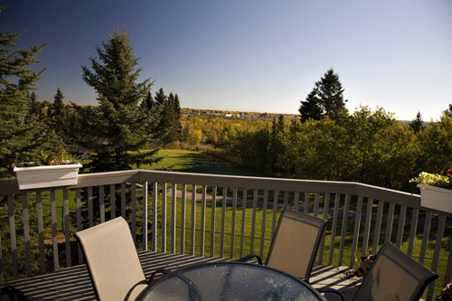**Financial Freedom Tip of the Month**

*Here’s what others are saying…*

Wow! What a great experience purchasing our first home! You were knowledgeable, professional, and extremely attentive to all of our needs. As first time buyers, we had many questions and you were able to answer them all, as well as offer us valuable advice on the real estate market. You were highly organized and thorough in your research of properties, plus you were always available when we needed to meet with you. Thank you! **~John and Tammy Smith, Vancouver, BC**

**Shannon Lancy**

Realtor*®*

(413) 269-6958

shannonlancy.com

info@shannonlancy.com

Office Address: 123 Any Street, Any Town, Any Province, 123456

**Awesome 4 Bedroom Home!** 4 Bedrooms, 2.5 Baths, 3 Car Garage**,** 2,325 sq. ft.**,** beautiful hardwood floors throughout**,** master suite with 3 piece master bath**,** professionally landscaped yard**,** large rear deck and patio**. Text code: “Buy124”**

**Your Dream Home Awaits!** 4 Bedrooms, 2.5 Baths, 3 Car Garage**,** 2,325 sq. ft.**,** beautiful hardwood floors throughout**,** master suite with 3 piece master bath**,** professionally landscaped yard**,** large rear deck and patio**. Text code: “Buy123”**

Text the code below to 79564 to receive more info – including **PRICE & FINANCING OPTIONS:**

**Stunning Lakeside Cabin!** 4 Bedrooms, 2.5 Baths, 3 Car Garage**,** 2,325 sq. ft.**,** beautiful hardwood floors throughout**,** master suite with 3 piece master bath**,** professionally landscaped yard**,** large rear deck and patio**. Text code: “Buy126”**

**Countryside Beauty!** 4 Bedrooms, 2.5 Baths, 3 Car Garage**,** 2,325 sq. ft.**,** beautiful hardwood floors throughout**,** master suite with 3 piece master bath**,** professionally landscaped yard**,** large rear deck and patio**. Text code: “Buy125”**

An easy way to calculate how much house you can afford.

Before starting to look for that perfect home, take a close look at your finances. The reality is your dream home will remain a dream if you can’t afford it. Here’s how to determine how much house you can afford:

* **How much do you earn?** Sit down with your spouse and add up your total monthly household income.
* **How much can you afford to spend on mortgage payments?** It’s best not to spend more than 25% of income on mortgage payments. Multiply your monthly household income by 25% to determine the maximum monthly mortgage payment you can afford.



* **Use an online calculator to see how much home that will buy.** Plug these numbers into a calculator, along with estimated private mortgage insurance cost, property taxes, homeowners association fees, etc.
* **Don’t forget other expenses.** Remember, homeownership comes with additional costs like utilities, new appliances, ongoing repairs and maintenance. Estimate how much this will add to your monthly expenses.
* **Consider down payment.** The bigger your down payment, the lower your mortgage payments. Plus, if you can save a 20% down payment, you’ll avoid private mortgage insurance. But saving a larger down payment may delay your purchase.
* **Remember closing costs.** Like a down payment, closing costs are a significant one-time expense. They can amount to 4% of the purchase price, and include appraisal, attorney, credit report, home inspection, etc.

**Holistic Health Tip of the Month**

**Quiz Question of the Month**

1. **Mostly water.** This is a good thing! Your body needs several liters of liquids per day. Eating an orange is a delicious way to drink water!
2. **Antioxidant properties.** The flavonoid antioxidants in oranges provide [anti-inflammatory*,* antiviral, and antimicrobial](https://pubmed.ncbi.nlm.nih.gov/28497905/?from_term=citrus+antioxidants&from_pos=1) benefits, and they’re linked to lower depression risk and reduced weight gain.
3. **Flavonoids in the peels too.** Flavonoids in organic citrus peels may help prevent the growth of cancer cells.
4. **The juice is nutritious too.** Think of orange juice as a serving of fruit (with less fiber). Drinking citrus juice is linked to improved cognitive function in older adults and enhanced blood flow to the brain in young adults.
5. **Versatile enough to be included throughout your diet.** Aside from eating a raw orange or drinking juice, you can add nutrition to meals by throwing oranges into salads, stir fries, cereals, whole grain dishes and yogurt.

We all know oranges are good for us. But how are they good for us? Here’s what makes oranges so nutritious:

1. **Rich in vitamin C.** Everyone knows this benefit! One orange has about 80% of the daily requirement of vitamin C.
2. **High in fiber.** Fiber supports digestion, regulates blood sugar and improves bowel function. A medium orange contains 3 grams of fiber.
3. **Good source of potassium and folate.** Potassium supports heart function and muscle mass. Folate promotes brain and nervous system function.

8 reasons why oranges are good for you.

March Trivia Question

Which of the following celebrities WASN’T born on St. Patrick’s Day, March 17?

1. Rob Lowe
2. Lady Gaga
3. Nat King Cole
4. Kurt Russell

**Answer to Last Month's Quiz**

February 2 is Groundhog Day. What order of mammals do groundhogs belong to?

* 1. Primate
  2. Carnivora
  3. Rodent
  4. Lagomorpha

ANSWER: c) Rodent

**How does this contest work?**

The first person to respond with the correct answer will win a FREE Dinner for themselves and another guest couple of their choice!

**How do I submit my answer?**

To respond with your answer, email us: email@yourweb.com or fax (xxx-xxxx) in your answer with the enclosed “Free Info” request form. The contest deadline is MM/YY.

**ANNOUNCING LAST MONTH’S WINNERS!**

Congratulations to Sarah and Dan Penner of North Vancouver for winning last month’s quiz contest! They have won a FREE dinner for themselves and another couple at the Salmon House in West Vancouver. Enjoy!

**Resource of the Month**

Buying a home is a BIG deal. Here’s how to avoid making BIG mistakes!

If it’s gotten to the point that owning a home is cheaper than renting, that’s a good indication that it might be time to buy. But deciding to buy a home isn’t as simple as that. There are lots of financial and lifestyle factors that need to be taken into account. And at every step, there’s the chance you’ll make a mistake that could cost you BIG!

That’s why I’m offering you an exclusive FREE report entitled *“15 Mistakes Homebuyers Make and How to Avoid Them”*. As your local mortgage experts, we make it our business to make the home buying process as simple, affordable and risk-free as possible. This report is full of essential tips that can help you make better decisions and avoid costly errors. Inside, you’ll learn how to:

**DELETE THIS AFTER READING!**

You can access the Home Buyer Guide here: <http://bit.ly/1SEoCIR>

* Narrow down your search criteria before you start shopping.
* Get pre-approved instead of pre-qualified.
* Navigate all the lenders, offers, rates and qualification requirements.
* Get approved when your bank says “no”.
* Use Realtors strategically.
* Make sure the home doesn’t have any hidden problems.
* And more!

Don’t venture out into the real estate market on your own. Arm yourself with this report so you can avoid costly mistakes. To get your complimentary, no-obligation copy today, call our 24-hour info hotline at: 1-800-123-1234 Ext. 235.

As you can see, we’ve got a growing selection of free reports that are jam-packed with valuable tips and proven strategies to help you and your friends and family avoid costly financial pitfalls. If you’d like us to rush you one or more of these free reports, please fill out the reply form below and submit it by fax: 1-800-XXX-XXXX or snail mail it to: 123 any street, any town, any province, postal code.

Have you gained value from this newsletter? If so, we want to invite you to “pay it forward” by giving the **GIFT of a FREE SUBSCRIPTION** to your friends, co-workers, relatives, business acquaintances, etc. Simply fill out the info on the “Subscribe-a-Friend” form at the bottom of this page, and we’ll send them a free subscription. As a courtesy to you, we’ll also enclose a special note along with their first issue telling them that you asked us to surprise them with this free gift. And of course, they can contact us any time if they’d like to cancel. If you’ve been enjoying our newsletter, this is your hassle-free opportunity to share it with the people you care about - for FREE!

**“Do You Have All the Information You Need To Make An Informed Decision About Buying, Selling, or Refinancing Your Home?”**

###### YES! Please send the FREE Report(s) I’ve selected below: To Get Your Free Copy of Any Of These Reports Simply Call our 24hr Hotline 1-800-XXX-XXXX or Check Off The Ones You Want On This Form And Mail/Fax It In!

**Press Extension:**

[ ] “9 Secrets to Make Your Home Reno Pay for Itself” - Ext. 1310

[ ] “7 Facts You Need to Know About Reverse Mortgages” - Ext. 1311

[ ] “7 Steps to Stop Paying Rent and Own a Home Instead” - Ext. 1312

**YES!** **I’d like** **your trusted advice and counsel about:** _____ Getting a Mortgage _____ Refinancing _____ Other

**Your Contact Information:**

First Name ____________________________ Last Name _______________________________ Best time to contact _______________

Address _______________________________________________________________________________________________________

City _____________________________________________ State ________________________ Zip Code _______________________

Phone _____________________________ Fax _______________________ Email________________________________________

**Don’t forget to send in your Client Quiz answer to win a FREE DINNER! Submit your answer by fax, mail or email.**

Also, please contact me to help me with: _____ Getting a Mortgage _____ Refinancing

**Don’t forget to send in your Client Quiz answers to win a FREE DINNER!**

**My answer for the Client Quiz of the Month is:** ________________________________________________

Also, please contact me to help me with: _____ Getting a Mortgage _____ Refinancing

**Don’t forget to send in your Client Quiz answers to win a FREE DINNER!**

**My answer for the Client Quiz of the Month is:** ________________________________________________

### “Free Info” Request Form

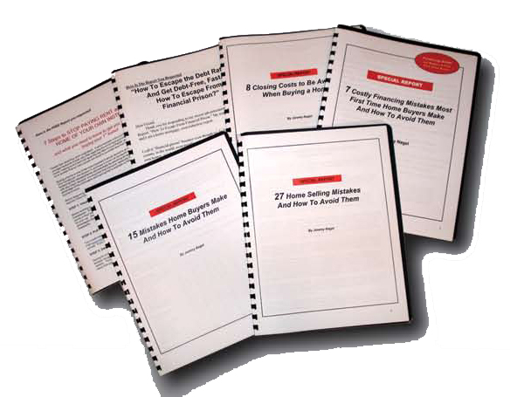

**Subscribe-A-Friend Request Form**

**[ ] YES! Please give the following people a FREE subscription to your monthly newsletter. I understand you’ll enclose a special note informing them that I asked you to surprise them with this free gift, and that all they have to do is contact you if they wish to cancel.**

Full Name _____________________________________________ Address ____________________________________________  
City _______________________________________________ State _________________________ Zip Code ________________

Fu Full Name _____________________________________________ Address ____________________________________________  
City _______________________________________________ State _________________________ Zip Code ________________

Please use the back of this form if you need more room. Remember to submit your Quiz answers to win a FREE dinner!



BEFORE YOU SEND OUT YOUR NEWSLETTER YOU MUST READ THESE IMPORTANT INSTRUCTIONS!

Dear Done4U Newsletter Member,

I want to make sure you understand how to get the most value from your Done4U client newsletter so you can build Top of Mind Consciousness with your prospects, clients and referral sources and maximize your referrals and repeat business.

Here are the critical steps you must take to ensure success with your newsletter:

**STEP #1:** Watch the orientation video to learn how to customize your newsletter. Just go to: <http://budurl.com/customizeletter> (personalize all text in red then turn it back to black).If this is not your FIRST issue, be sure to add in the answers to last month’s quiz and announce the winners.

Things to customize:

* Header
* Name of Newsletter
* Pic and Contact info (page 1)
* Client News
* Quiz of the Month: a) How to respond b) Last month’s winners
* Resource of the Month: Contact Info
* Free Info Request Form
* Cover Letter (If Applicable)
* Contest Insert (If Applicable)

**STEP #2:** If there are any articles included in this month’s issue that you don’t want to include, you can easily replace it with another article found in our article archive here: <https://b.link/articlearchive>

**STEP #3:** Get access to the customizable Done4U Lead Generation Reports at: <https://b.link/consumerguides>

**STEP #4:** If this is your inaugural issue, be sure to also enclose the following...

a) For your own newsletter [use this cover letter](https://drive.google.com/file/d/1yQDGiVE_1R9erCDH_EJQ9mMq9ybRmGNU/view?usp=sharing).

c) Consider adding the “Contest Insert” to explain the contest.

**STEP #5:** Send the customized file to your printer or send it to a fulfillment vendor to do it all for you. Find our recommended vendors at: [www.DorenRecommends.com](http://www.DorenRecommends.com).Be sure to get your newsletter in the mail by the 10th of each month or earlier.

**IMPORTANT:** be sure you follow these specifications…

* If you are printing full color, print double sided on white 11X17 paper
* If you are printing full black ink, print double sided on 11X17 colored paper (pastel green, canary yellow, or golden rod)
* Fold like a booklet
* If you choose to use a larger envelope than a basic No.10 envelope use the envelope document I provide and print the teaser copy on the front. You can also have it be a self-mailer (without an envelope), which makes it much more cost-effective to mail. Ask your fulfillment vendor for the difference in price between those two options.
* Use blue handwriting font for the return address and mailing address (no company name or logo)

Always use a separate colored color 8 ½ X11 sheet for the response form. If you use colored paper for the newsletter use white paper for response form.

**STEP #6:** Send a prize for your Quiz of the Month! The answer to this month’s quiz is…

ANSWER: B. Lady Gaga was born March 28, 1986